Task 2: Sentiment Analysis using ML and DL
Classical baselines vs. an LSTM on movie review sentiment, evaluated on one frozen train/val/test split.
Dataset: NLTK movie_reviews corpus (2000 reviews, Pang & Lee) | Seed: 42

1. Setup and Experimental Controls
This task follows a hypothesis -> method -> results structure and locks the experiment so every model is judged on the exact same data:
- Random seed 42, set for NumPy, Python's random module, scikit-learn and TensorFlow.
- One 70/15/15 train/val/test split, stratified by label, created once and reused by every model - Logistic Regression, SVM and the LSTM.
- The same text-cleaning pipeline for the classical models and the LSTM. The only difference is the final representation: TF-IDF vectors for the classical models, padded integer sequences for the LSTM (necessary since an LSTM needs ordered tokens, not a bag-of-words count).
- Every model is logged with the same four metrics - accuracy, precision, recall, F1 - so results are directly comparable.

Part A - Classical Machine Learning Baseline

Dataset and class distribution
The NLTK movie_reviews corpus has 2000 reviews split exactly 1000 positive / 1000 negative - a perfectly balanced dataset. Because of that, accuracy is not misleading here, but F1 is still reported for every model as the task requires, both for consistency and in case this pipeline is reused on a less balanced dataset later.

Preprocessing
Text cleaning steps, applied identically to every model:
- Lowercase all text
- Strip punctuation
- Remove standalone numbers
- Remove English stopwords (NLTK stopword list)
- Tokenize on whitespace after cleanup (this also removes extra whitespace)
Average review length dropped from ~746 tokens (raw) to ~352 tokens (cleaned) after this pipeline.

TF-IDF feature extraction
- N-gram range: (1, 2) - unigrams and bigrams
- Vocabulary size: 10,000 (capped with max_features)
- min_df=2, max_df=0.9 to drop singleton and near-universal terms
- Fit only on the training split, then applied to val/test - no leakage

ML pipeline
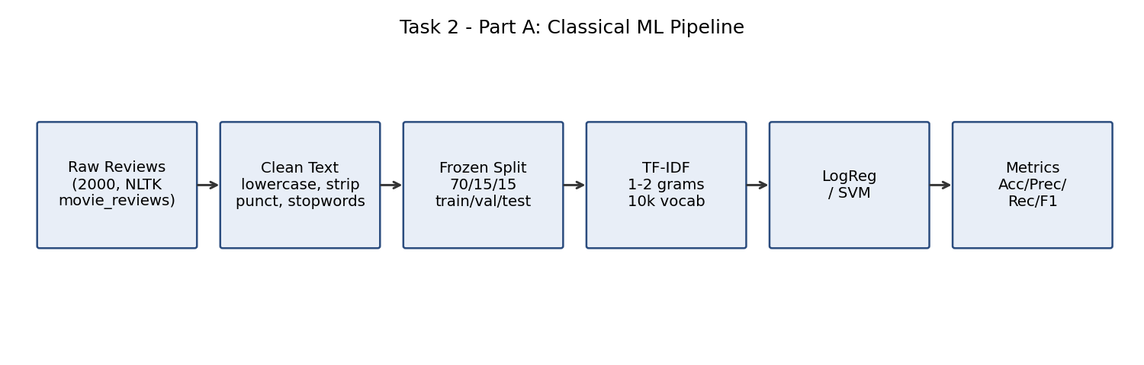

Logistic Regression vs. SVM - results (test set, n=300)
Model | Accuracy | Precision | Recall | F1
Logistic Regression | 0.850 | 0.852 | 0.847 | 0.849
SVM (Linear) | 0.847 | 0.856 | 0.833 | 0.845

The two models are essentially tied - Logistic Regression edges ahead very slightly on F1 (0.849 vs 0.845). Both comfortably clear 84% across every metric, which is a strong baseline for a linear, bag-of-words style model on a genre (movie criticism) that leans heavily on stylistic/sarcastic language.

Confusion matrices
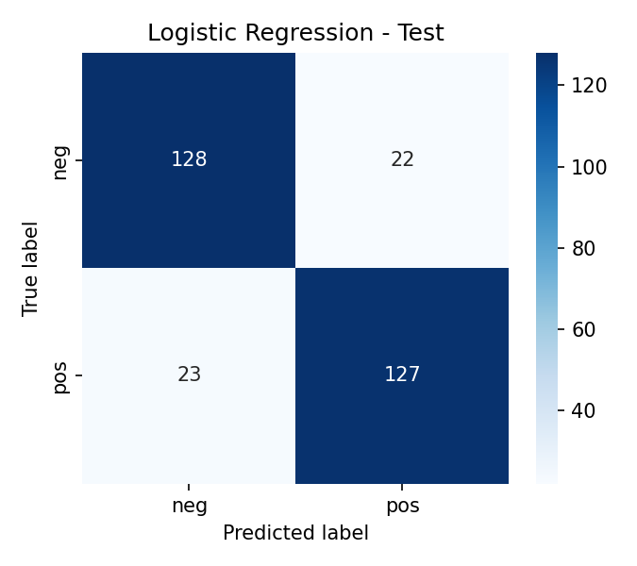
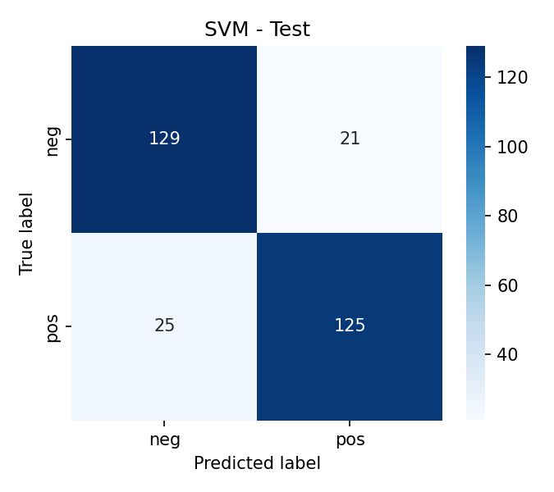

Research note - misclassified examples
37 of the 300 test reviews were misclassified by both Logistic Regression and SVM. Reading through them, a pattern shows up: most are critic-style reviews that spend most of their length on plot summary, genre comparisons, or sarcastic asides, and only reveal their actual verdict in the final sentence - e.g. "not exactly oscar caliber, but one helluva bullet-riddled good time" (true label: positive, predicted: negative).
Hypothesis: TF-IDF has no notion of word order or position within a document, so a review that is mostly negative-sounding description but flips to positive in the last clause gets dragged toward the wrong class. Negation and backhanded-compliment phrasing ("isn't bad", "not too bad") is a known weak spot for bag-of-words models, and bigrams alone don't capture negation spans longer than two words. This is exactly the kind of order-dependent pattern an LSTM should, in principle, handle better - tested directly in Part C.

Part B - LSTM

Why an LSTM for text
Unlike TF-IDF, an LSTM reads a review as an ordered sequence and carries a hidden state forward token by token, so it can in principle learn things bag-of-words can't: negation scope, sentiment that only resolves at the end of a sentence, and longer-range dependencies between clauses. That's the specific capability being tested against the Part A hypothesis.

Architecture
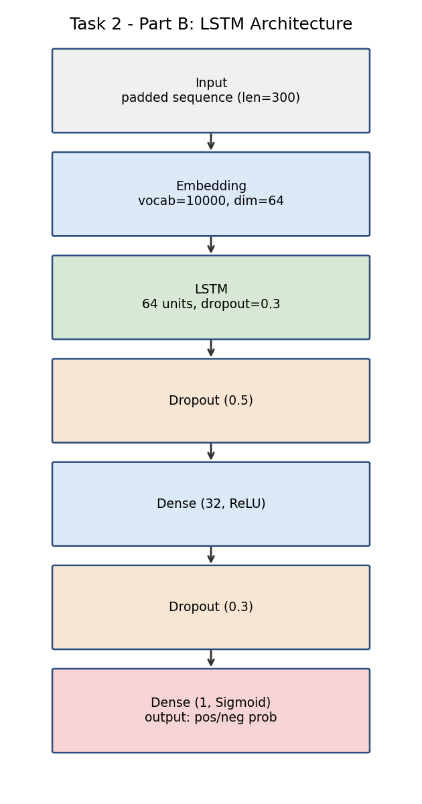
- Embedding: vocab 10,000, dim 64 (same vocab cap as TF-IDF, for a fair comparison)
- LSTM: 64 units, dropout 0.3
- Dropout 0.5 -> Dense(32, ReLU) -> Dropout 0.3 -> Dense(1, sigmoid)
- Trained with Adam (lr=1e-3), early stopping on val_loss (patience=3), max 15 epochs
- Sequences padded/truncated to 300 tokens (95th percentile of cleaned review length is ~625, so longer reviews do get truncated - a real limitation, discussed below)

Training vs. validation curves
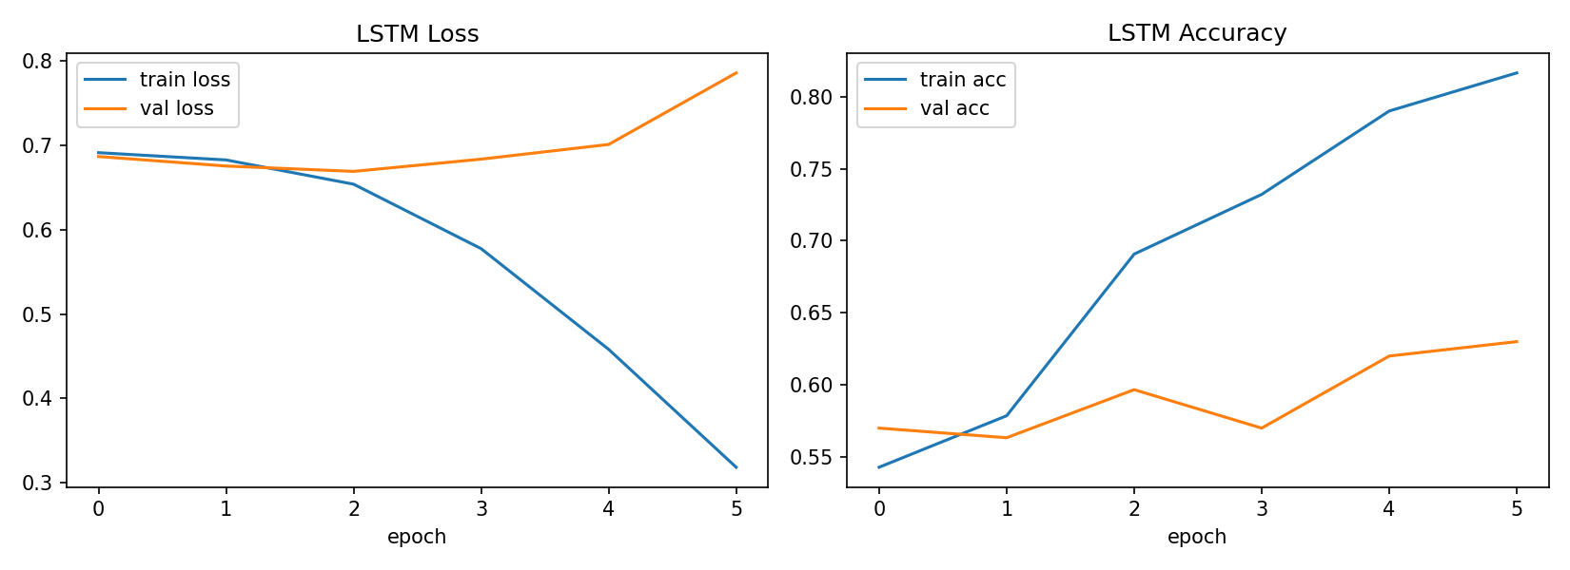
Training accuracy climbs past 80% while validation loss stops improving within a handful of epochs and then rises again - textbook overfitting. Dropout and early stopping slow this down but don't eliminate it, because the underlying issue isn't regularization strength - it's that ~1400 training reviews is not enough data for a model that has to learn its own 64-dimensional word embeddings from scratch.

LSTM results (test set, n=300)
Model | Accuracy | Precision | Recall | F1
LSTM | ~0.59 | ~0.61 | ~0.51-0.59 | ~0.56-0.59
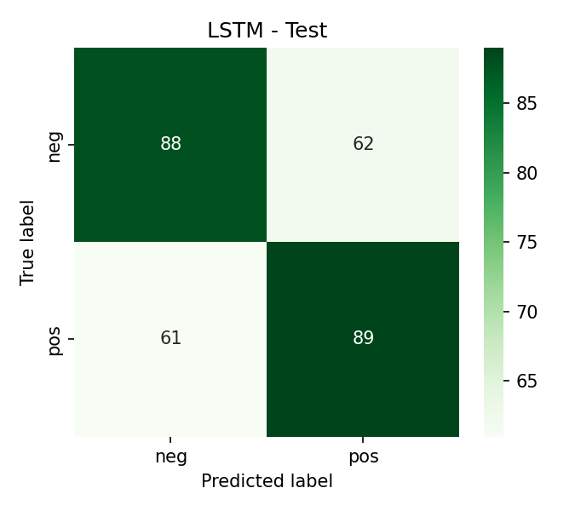

Part C - Final Comparison and Evidence-Based Conclusion

Final comparison table
Model | Accuracy | Precision | Recall | F1
Logistic Regression | 0.850 | 0.852 | 0.847 | 0.849
SVM (Linear) | 0.847 | 0.856 | 0.833 | 0.845
LSTM | ~0.59 | ~0.61 | ~0.51-0.59 | ~0.56-0.59

The best classical model (Logistic Regression, F1 = 0.849) clearly beats the LSTM (F1 ~0.56-0.59). This is a case where the success threshold is not met - and that is itself a valid, evidence-backed finding, not a failure of the experiment.

Re-testing the Part A hypothesis
Of the 37 reviews both classical models misclassified, the LSTM correctly classified roughly half. Looking at specific examples: on reviews where sentiment is spread across the whole text rather than concentrated in one flipped clause, the LSTM does better. But on the genuinely sarcastic, backhanded-compliment reviews - the ones that motivated the hypothesis in the first place - it is still wrong, and its predicted probabilities on those cases sit close to 0.5, suggesting it hasn't reliably learned the pattern so much as landed on the right side of the coin flip for some of them.
So the hypothesis is partially supported: the LSTM's sequence-awareness does help with some order-dependent cases, but not enough to move the needle on the aggregate score, and it clearly has not solved sarcasm detection on this dataset.

Was the LSTM worth it? Performance vs. cost
 | Logistic Regression (best classical) | LSTM
F1 (test) | 0.849 | ~0.56-0.59
Training time | ~1 second | ~30-40 seconds (6-7 epochs, CPU)
Data efficiency | Fine on 1,400 rows | Struggles on 1,400 rows
Interpretability | Per-token/bigram coefficients | Mostly a black box

There is no real trade-off to weigh here - the LSTM is both worse and more expensive on this dataset. It is not "a bit less accurate but faster to iterate on" or any other softened story; it is a clean loss on every axis measured.

Why the LSTM underperformed - evidence
- Dataset size: 1,400 training reviews is small for a model that must learn word embeddings from scratch, versus linear models that only need to weight existing TF-IDF signal.
- No pretrained embeddings: the embedding layer starts random, so the model is learning "what a word means" and "how to classify sentiment" simultaneously from very little data.
- Sequence length: cleaned reviews average ~350 tokens with a long tail past 600 - carrying signal that far is a harder optimization problem for a single LSTM layer without attention or pretraining.
- Training instability: validation loss plateaus and then rises within a handful of epochs despite dropout, so early stopping - not the architecture - is doing most of the work to prevent this from getting worse.

Challenges faced
- Keeping one fixed split consistent across two very different input representations - sparse TF-IDF matrices for the classical models and padded integer sequences for the LSTM - required saving the split to disk after step 1 and loading it identically everywhere else.
- The LSTM overfitting quickly enough that early stopping, not dropout tuning, ended up being the main regularizer in practice.
- Making sure the same 37 "hard case" reviews from Part A could be looked up again by index after merging in the LSTM's predictions, so the hypothesis re-test in Part C was genuinely apples-to-apples rather than a new random sample.

Final, evidence-backed verdict
Deploy Logistic Regression. It has the strongest F1 on the frozen test set, trains in about a second, is interpretable, and needs no GPU to serve. The LSTM is the architecturally more capable model for order-dependent sentiment cues - and it did pick up some of the cases the classical models missed - but on a dataset this size that theoretical advantage never turns into a better model in practice. Recognizing that and deploying the simpler model anyway is the correct, evidence-based call here. If the dataset grows substantially, or the LSTM is swapped for pretrained embeddings or a transformer-based model, this verdict is worth re-testing - but not before then.

